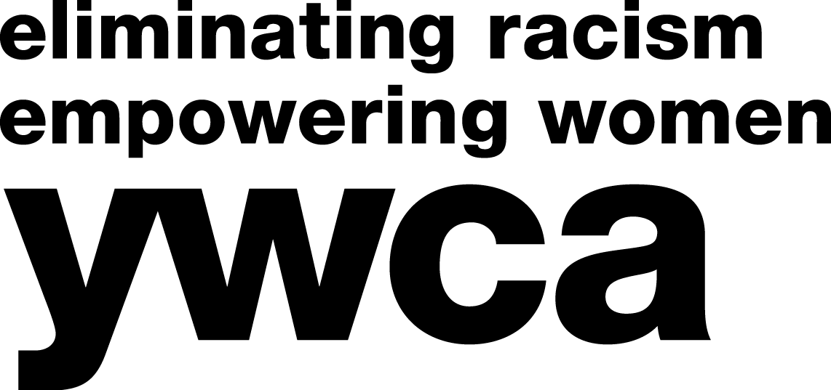
April 13, 2021

Senate on Education and Career Readiness
Room 403, Capitol Building
100 S. Capitol Avenue,
Lansing, MI 48933

Members of the Committee on Education and Career Readiness,

Michigan’s K-12 students of color are experiencing schools as a place of discrimination that leads to unwelcoming, unsafe, and unsupportive school environments. These experiences often prevent or discourage youth from completing their educational goals and is a practice known as school pushout. School pushout is an issue impacting Michigan’s students, particularly students of color, whereby disciplinary practices are being disproportionately administered - especially as they pertain to incidences of non-violent offenses. This letter is an intentional recommendation, encouraging the Michigan Senate Committee on Education and Career Readiness, to bring S.A.F.E. Student Act (SB68-69) to a public hearing and a vote.

Access to, and full participation in, education is essential to build healthy, safe, and equitable communities. For many of Michigan’s youth, schools can be supportive and nurturing places that allow each student to achieve their educational goals. In these uncertain times, schools play an important role in the life of a student. As schools across the country look to build supportive and inclusive spaces for students, and federal courts affirm a student's right to literacy and education, we must ensure that all youth can exercise their right to an education free from discrimination. This work has been and continues to be of great importance to our organizations and the communities that we serve every day.

Youth of color face social and structural barriers to accessing and attaining their educational goals. While bullying and a lack of school-based resources can contribute to school pushout, school disciplinary policies can also prevent students from meeting their educational goals. Disciplinary practices, like suspension and expulsion, not only impact students unequally but are administered to youth of color disproportionately. Nationally, Black, Latine, and Native American students receive substantially longer, harsher, and more school discipline than white students. Black students are also referred for discipline at higher rates for non-violent behaviors like "disrespect," or "excessive noise” compared to white students. In Michigan, Black students makeup 18% of the student population but makeup 45% of the state's "out-of-school" suspensions. Black girls and Black youth with disabilities experience suspension or expulsion at even higher rates than their white peers. LGBTQ+ youth of color not only experience bullying and harassment based on their race or ethnicity, but also report closer surveillance by school personnel, and receive harsher disciplinary measures.

Suspension and exclusion are increasingly applied to minor infractions, like absenteeism and truancy, even as more students are experiencing chronic absenteeism across hundreds of Michigan’s schools. Therefore, students already missing school are at a higher risk of falling further behind in their education. This is of particular concern amid COVID-19, as increasing strains on the financial, health, and technological capabilities of vulnerable families may result in decreased rates of attendance.

Disciplinary policies and practices like these criminalize youth. It can isolate them from their learning and social communities. Changing how we address discipline and its application is crucial in addressing the pushout of Michigan’s youth of color. Legislation, like the S.A.F.E. Student Act, is one way these issues can be addressed. SB 68-69 would ensure that no student continues to experience suspension or expulsion solely for being truant or chronically absent. These bills will also help to establish shared definitions, increases accountability through data reporting, and establishes a multidisciplinary Education and Equity Advisory Committee. We understand that equitable education is essential to building better communities. Therefore, we respectfully urge the aforementioned committee in the Senate to hold a public hearing for SB 68-69 - the S.A.F.E Student Act.

Sincerely,
Supported Organizations

YWCA Flint
YWCA Great Lakes Bay Region
YWCA Kalamazoo
YWCA Metropolitan Detroit
YWCA West Central Michigan
ACLU of Michigan
Grand Rapids Pride Center
Hispanic Center of West Michigan
Institute of Public Scholarship
Kalamazoo Community Foundation
Kalamazoo Virtual & Innovation Collaborative
KYD Network
Michigan Center for Youth Justice
Michigan Coalition to End Domestic & Sexual Violence
Michigan League for Public Policy
Michigan Organization of Adolescent Sexual Health (MOASH)
Soul Artistry LLC
Speak It Forward, Inc.
The Education Trust-Midwest
Urban Core Collective

